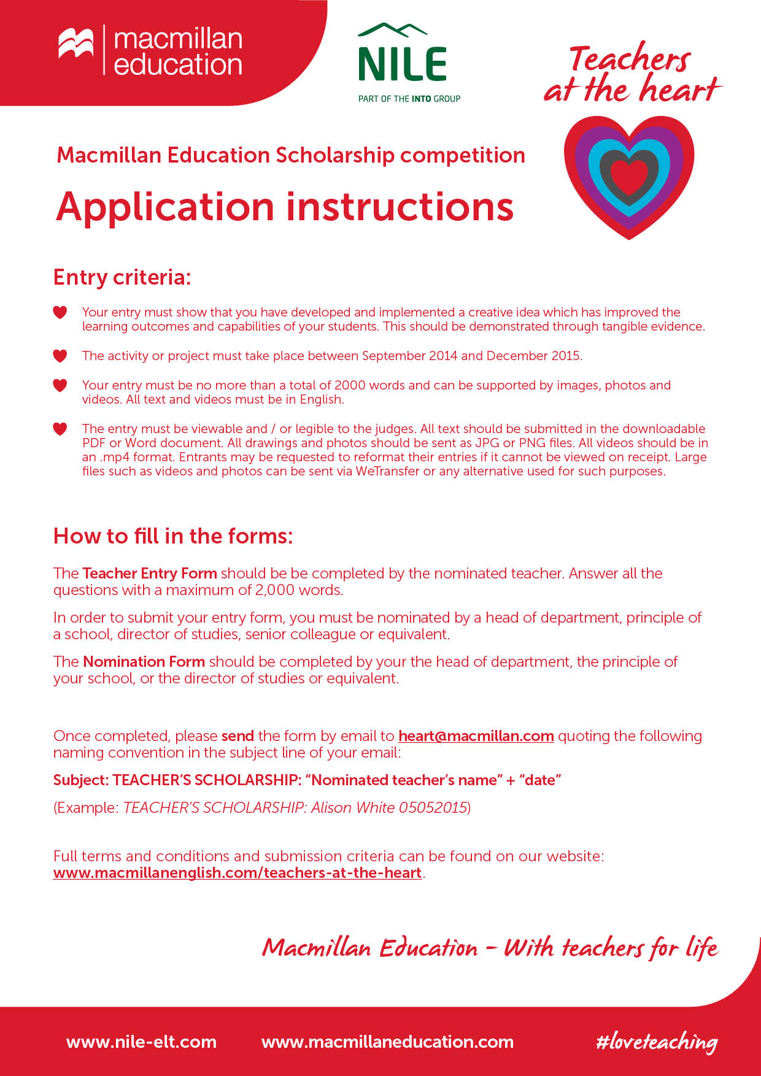

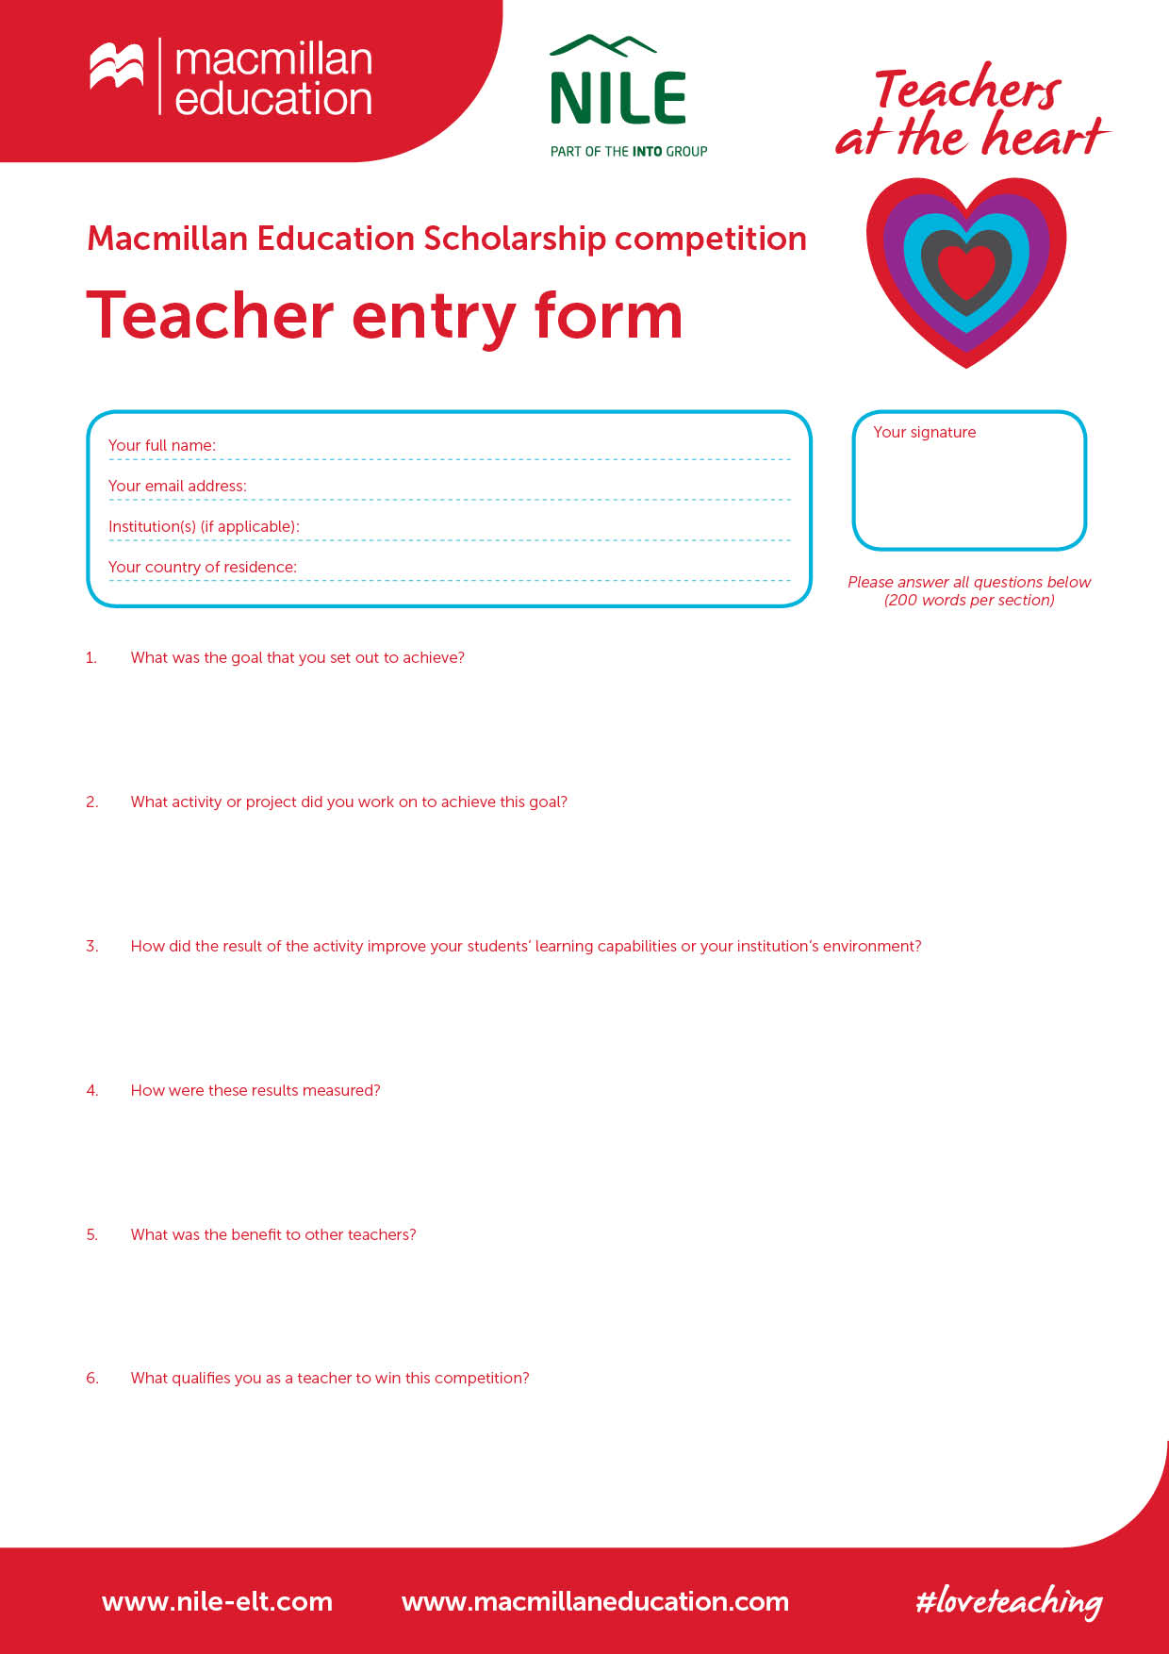

My experience of teaching English for about 30 years. My love to what I am doing. My love to my students and my profession. I would like to try out new teaching approaches and develop new ideas which I can get during a two weeks teacher training course…

Moreover, I am fond of the UK and its culture. It helps me to communicate with people, practice English and keep learning.

One of the biggest benefits I have found as a result of implementing this approach: I could share my experience with other teachers, my colleagues at my school and in our town.

My students made reports and performed participating in the language competitions. Their project works and presentations were published and the results were introduced on different sites in the Internet. They became winners and got diplomas.

It increased student engagement in the learning process and development of learning skills that will empower students once they leave school. They did research, created, discovered, did experimental exercises. They had the opportunity to immerse themselves in a dynamic learning environment where they are expected to take the responsibility for their learning instead of the teacher giving information to them. They got a chance to live in a discovery-based, open-ended experimental learning environment. It increased contact between students and their teacher. They became more self-confident practicing English.

To achieve this goal I organized research work and several project activities. My students made researches on topics they are interested in, solved different problems, looked for the information about history, art, literature of the English speaking countries. They took part in the local Research Conferences in our town Stupino Moscow Region, in the Competition of Electronic Presentations in English, in Local Language Competitions and different On-line Contests. They love to take part in the annual school project, musical show-competition called «Eurovision».To celebrate 150 years of «Alice in Wonderland» by Lewis Carroll we organized a project «Read! Watch! Draw!» My pupils read the book, watched the movie, learned tongue-twisters and drew a lot of pictures. One of them took part in the competition «Write about your Wonderland!» and created her own fictional story.

The main goal that I set out to achieve is to develop my students’ language skills: reading skills, writing skills, grammar skills, speaking skills and composition development. I do my best to inspire them, to make our English language learning journey more interesting, even breathtaking, to give them as much information as possible about the UK, its history, culture, national traditions and its people’ way of life. I try to guide them to discover much information for themselves with my role being «the guide on the side».

Russia

Secondary school №9 town Stupino

natasha_belova07@list.ru

Belova Natalia

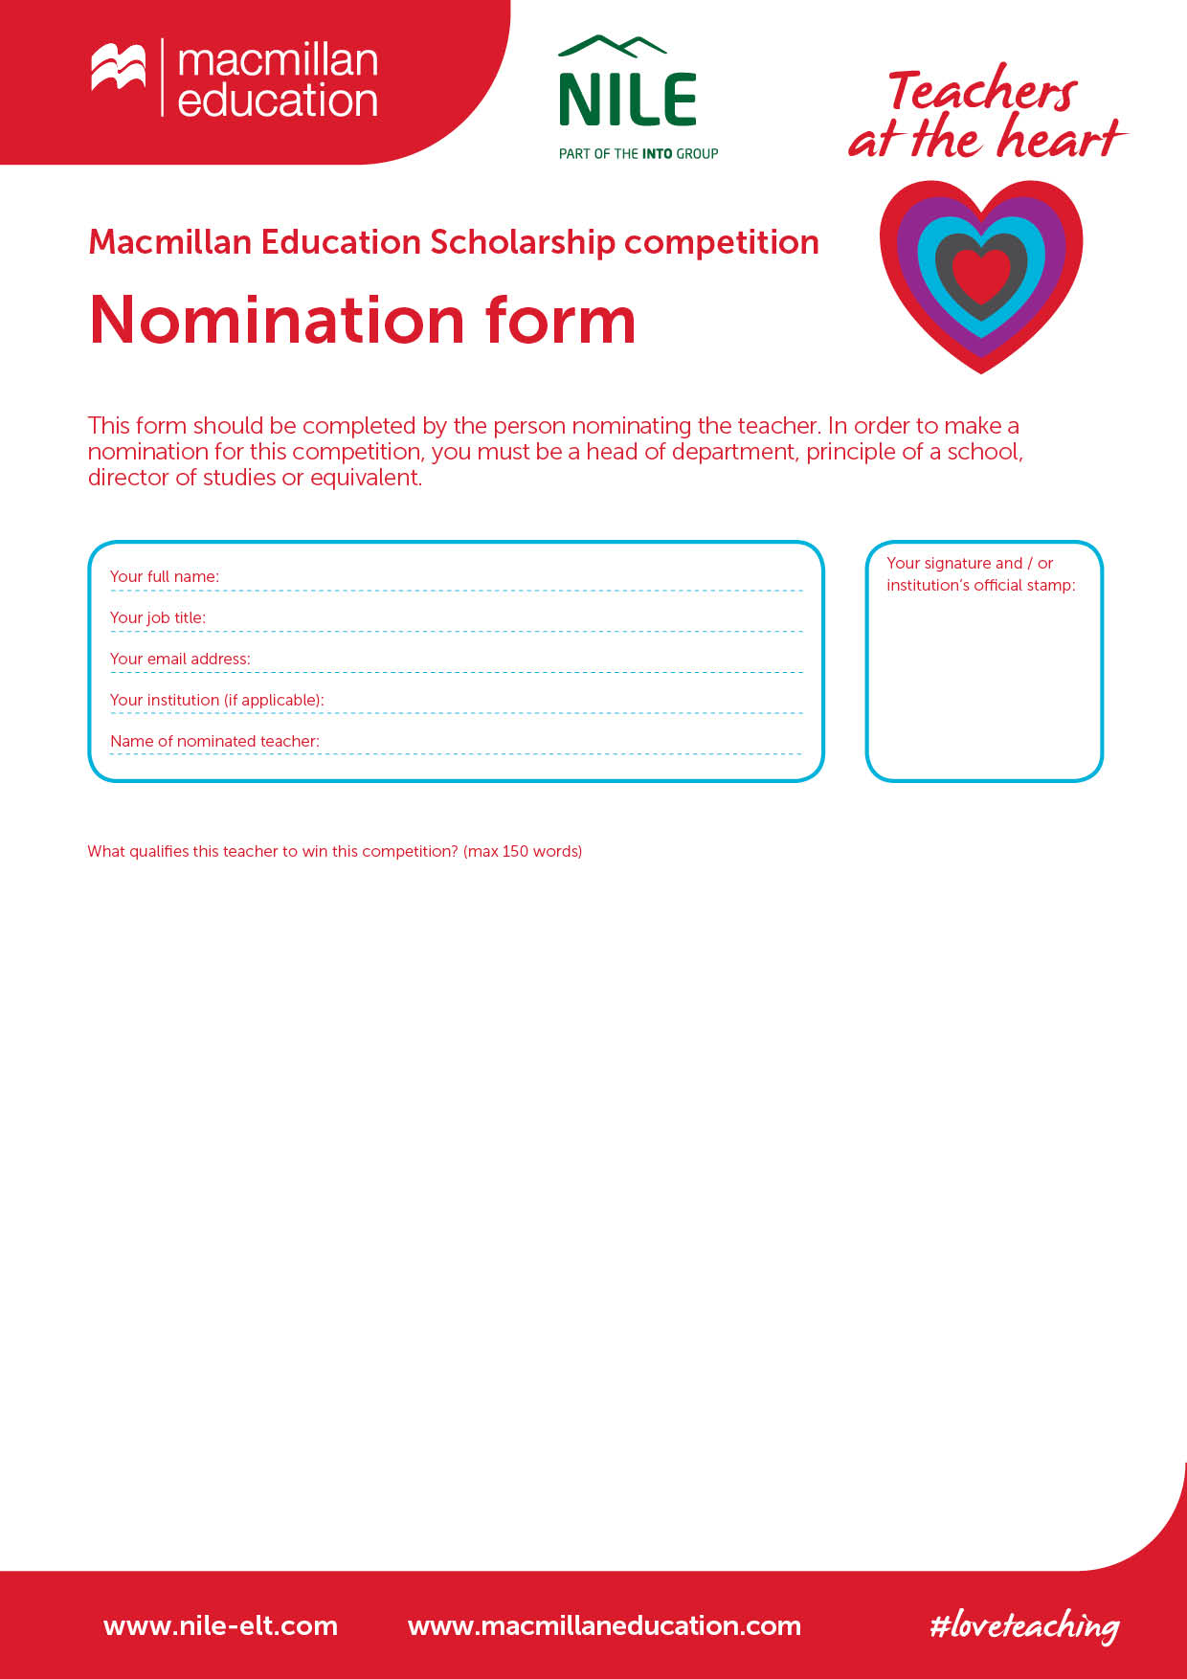

Natalia Victorovna Belova

Stupino secondary school №9

school-9st@mail.ru

Principle of the school

Galina Alexandrovna Ershova

Natalia Victorovna Belova has been working at school №9 since September 2012.

She is an experienced teacher. She has been working as a teacher of English for 33 years.

She is very fond of her job, loves her students, loves her profession. She is a teacher of the highest level of qualification.

She takes an active part in all language events at school and in our town professional community.

Last year her student of the 5th form Molchanova Varvara won the first prize in the town Competition of the Electronic presentations «How beautiful the world is!» with her presentation «My favourite book. Harry Potter». The student of the 9th form Malik Alexander became the third-prize winner in the All-Russian Language on-line Contest of the Project works on the site «1.September» *http://project.1september.ru/*

Natalia Victorovna Belova has been implementing Project activities for several years and shared her experience on the meeting of the Stupino English language teachers Community in November 2015.